**Key facts in UK**

1. Customers withdrew £6.8bn from their pensions in 2019
2. 332 Long-term savings providers.
   1. Number of authorised life insurance companies in the UK, of which 149 are UK authorised and 183 are headquartered in another European country and passport in under Freedom of Services.
3. Insurance & long-term savings: households and types of products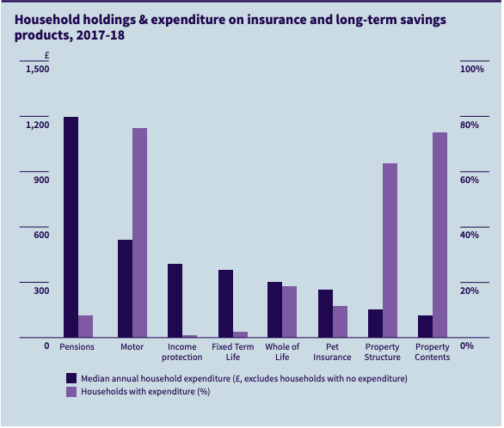
   1. 4.8 million had paid towards whole of life assurance
   2. 2.3 million had contributed to a personal pension
   3. 0.6 million had paid towards term life assurance
   4. 0.2 million had income protection

Rerirement: 25.1m number of individual pension policies in force.

(<https://www.abi.org.uk/globalassets/files/publications/public/key-facts/key_facts_2019_spread.pdf>)

**Global Insurance Industry Insights An in-depth perspective 2017**

(<https://www.mckinsey.com/~/media/mckinsey/industries/financial%20services/our%20insights/global%20insurance%20insights%20an%20overview%20of%20recent%20trends%20in%20life%20p%20and%20c%20and%20health/global-insurance-industry-insights-an-in-depth-perspective-may-2018.ashx>)

**THE FUTURE OF THE UK LIFE INDUSTRY**

(<https://www.oliverwyman.com/content/dam/oliver-wyman/global/en/files/insights/financial-services/2014/September/LON-MKT10307-001%20-%20Future%20of%20UK%20Life%20-%20FINAL.pdf>)

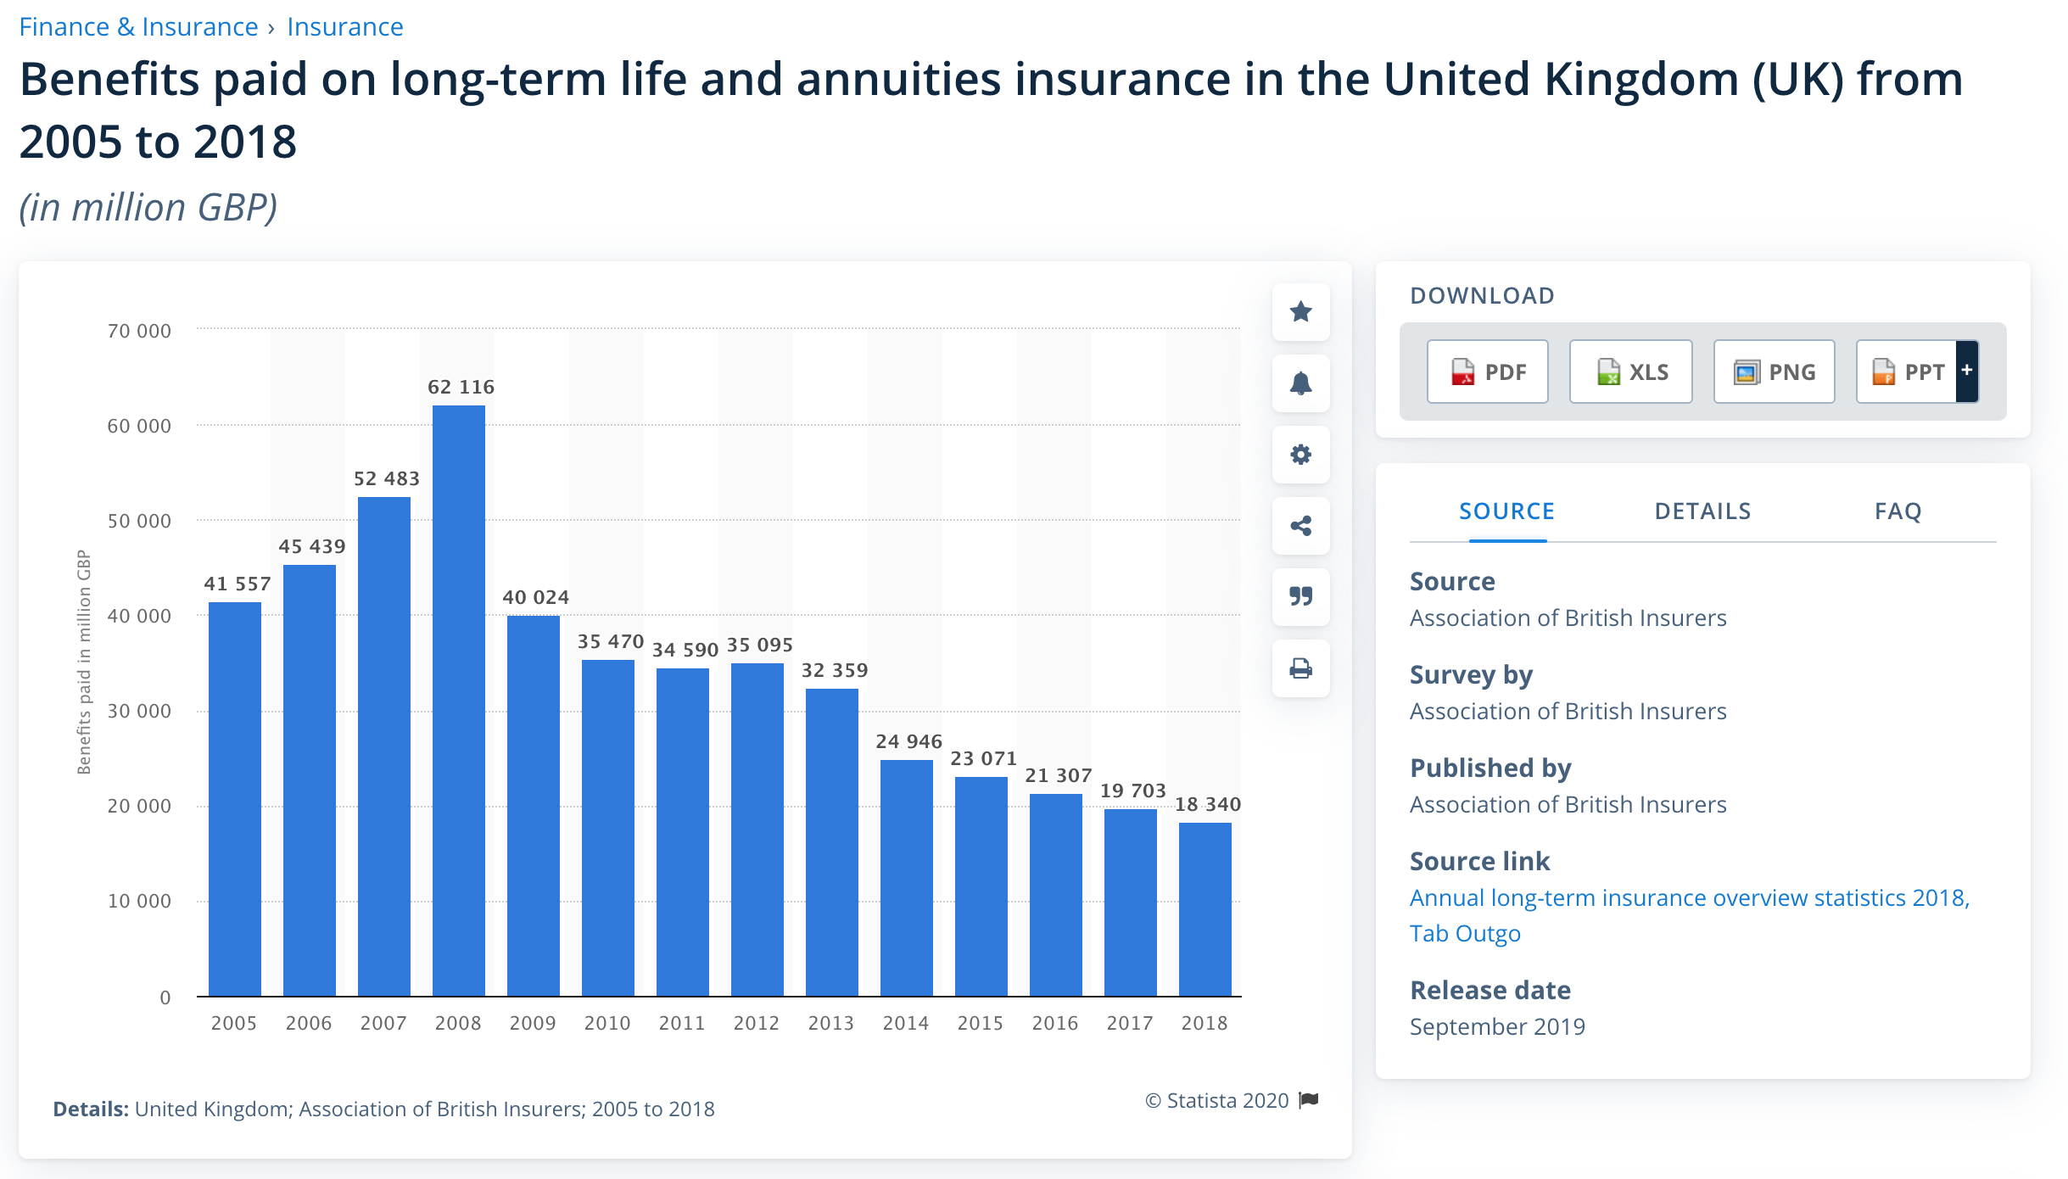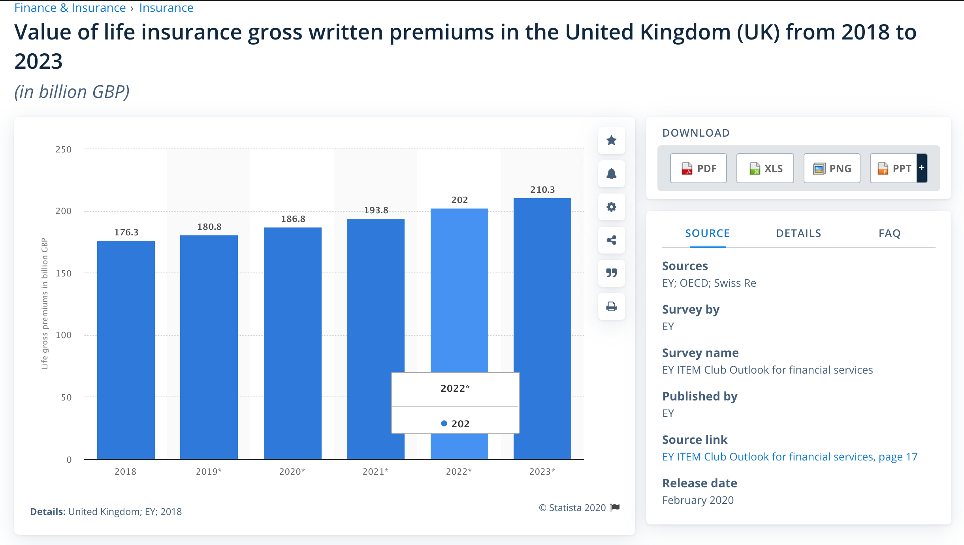

This statistic depicts the ranking of the most owned life insurance company plans in Great Britain from 2018 to 2019. In 2019, an estimated 2.88 million people owned Aviva life insurance plan, making it the leading life insurance company in Britain. That was an increase of 240 thousand people compared to the previous year. Ranked second and third were Legal & General and AXA GB.

(<https://www.statista.com/statistics/304398/company-life-insurance-plan-ownership-in-the-uk/>)

This statistic illustrates the market share of life insurance business in terms of gross premium (ratio of gross life insurance premium to total gross premium) in the United Kingdom (UK) from 2005 to 2018. It can be seen that life insurance market share decreased overall during this time, reaching a share of 71.7 percent in 2018.

(<https://www.statista.com/statistics/662640/life-insurance-market-share-united-kingdom-uk/>)

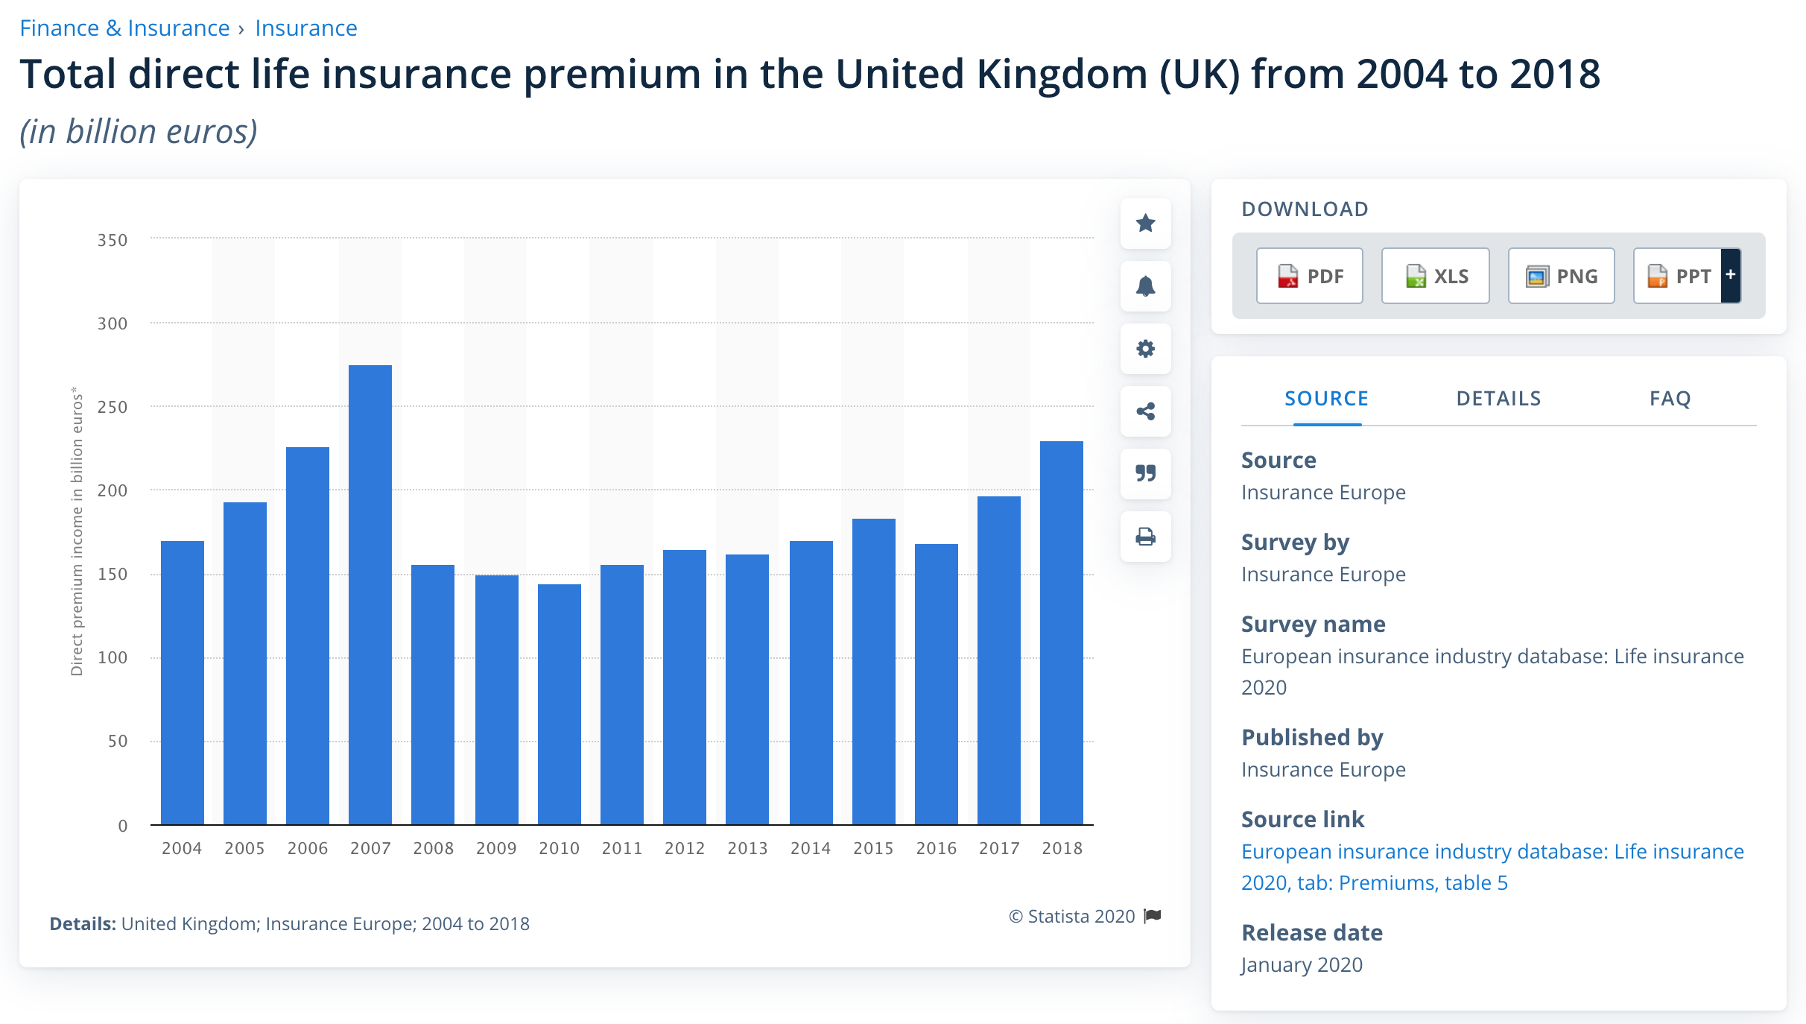

(<https://www.statista.com/statistics/283031/total-direct-life-insurance-premium-income-in-the-united-kingdom-uk/>)

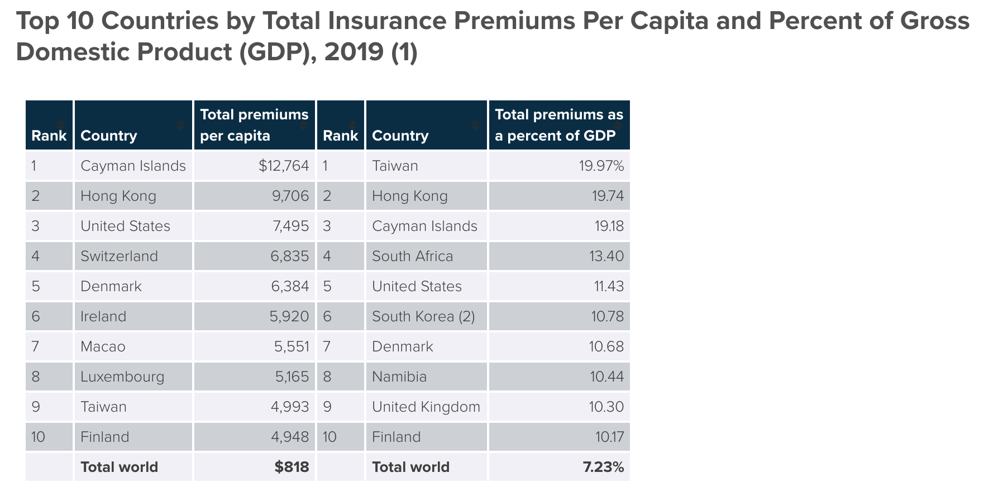

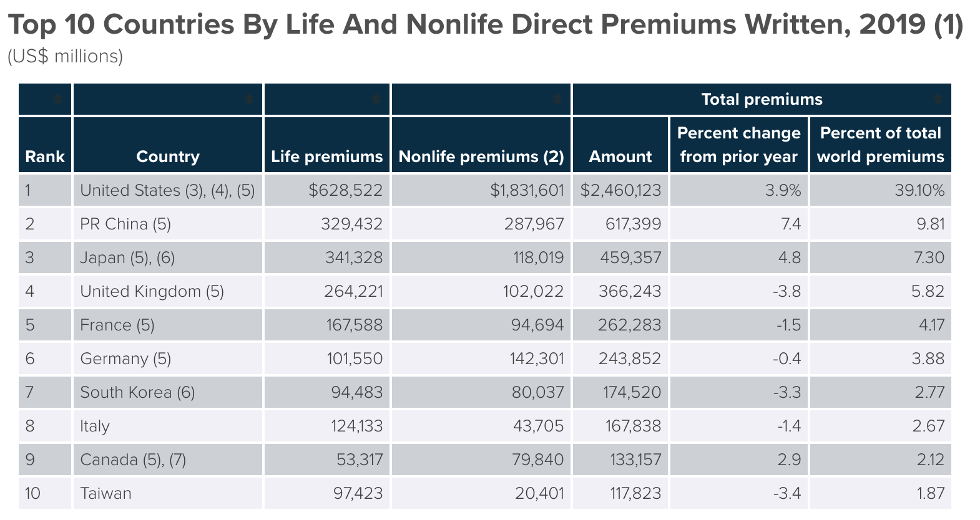

(<https://www.iii.org/publications/insurance-handbook/economic-and-financial-data/world-insurance-marketplace>)

**Nine of the biggest insurance companies in the UK ranked by gross written premium**

Gross written premiums: £11.2bn (2018)

Aviva is the biggest of the all the insurance companies in the UK, with a 17% market share of the life insurance and savings market, as well as a 10% share of the general insurance market.

(<https://www.nsinsurance.com/news/biggest-insurance-companies-uk/>)

**Insurance indicators  : Life insurance share**

(<https://stats.oecd.org/Index.aspx?DataSetCode=INSIND>)

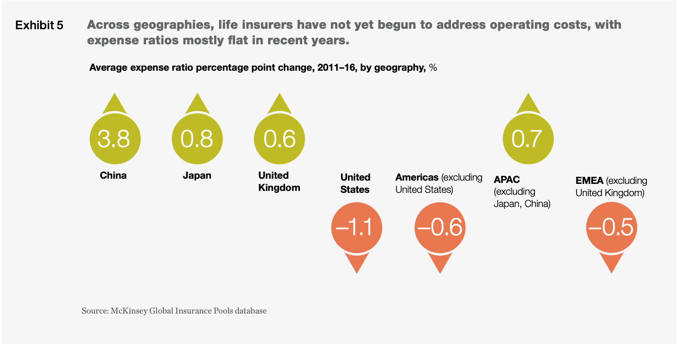

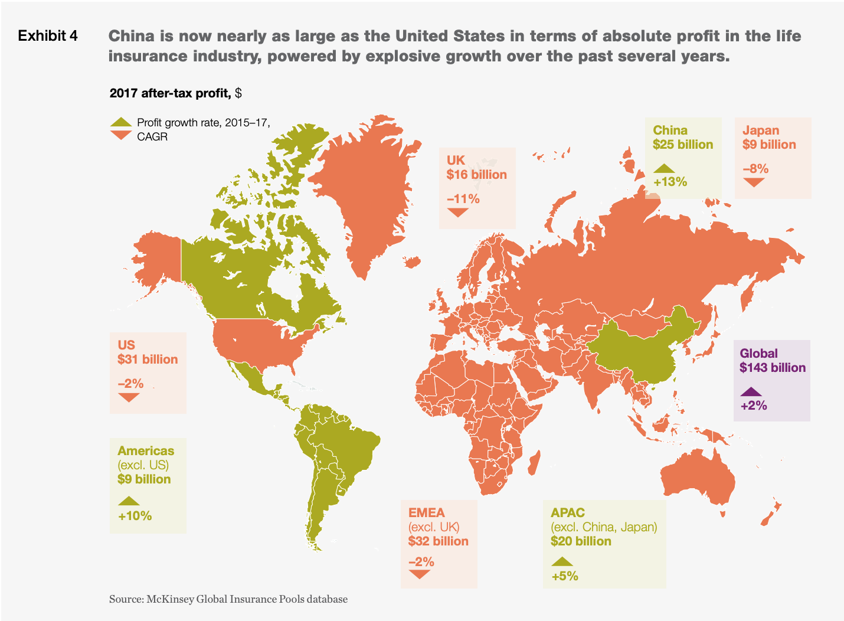

**(**<https://www.mckinsey.com/~/media/mckinsey/industries/financial%20services/our%20insights/where%20the%20life%20insurance%20industry%20can%20go%20from%20here/life-insurance-and-annuities-state-of-the-industry-2018.pdf>**)**

**Life Insurance**

There are two types of Life insurance policy:

1. Term life insurance policy: Policies taken out to cover a fixed period of time with a payment only made out if death occurs during the agreed ‘term’ of the policy.
2. Whole of life policy: A sum paid out regardless of time of death as long as premiums are paid.

Payouts can be given to beneficiaries either as a lump sum or through regular payments over a certain period. The latter ensures that the Life insurance policyholder with reassurance that their dependants will be looked after financially in the event of their death.

This can take the form of a regular allowance or mortgage payments if specified by the policyholder (instead of one lump sum).

(<https://www.insurancebusinessmag.com/uk/commercial-insurance-coverage-area/life-27/>)

**Compulsory and Voluntary Annuities Markets in the UK**

(<https://core.ac.uk/download/pdf/12824658.pdf>)

**Life and Long-Term Savings - ABI annual report**

1. Automatic enrolment continues to bolster the long-term savings market-
   1. By the end of February 2018 all UK employers were required to have set up a pension scheme and automatically enrolled all eligible employees. This completed a phased approach by size of employer, beginning in 2012 with the largest companies setting up their automatic enrolment schemes.
   2. From April 2019, contribution rates are due to increase again, to 8% with at least 3% provided by the employer, and there is a further chance that individuals may be put off by high contribution rates and opt out of the scheme. Recent news showed high opt out rates from NHS pensions, where employee contribution rates are between 5% and 14%.
2. Pension flexibilities and the retirement market-
   1. DB(defined benefit) to DC(defined contribution) transfers
      1. Through 2017, we saw an apparent increased level of these transfers. In the half year October 2017 to March 2018, 19,700 DB to DC transfers were recorded by ABI members. This was an increase of 86% on the 10,600 reported in the preceding six months and a further drastic increase from the 3,200 reported for October 2016 to March 2017. The value of these of these transfers also seems to be high, with an average value of £404,000 recorded in the year from April 2017 to March 2018.
      2. While some of the reported increase may be explained by improved reporting, there are other indications that the quantity of DB to DC transfers has indeed been increasing. DB transfers can be made into personal pensions and Self Invested Personal Pensions (SIPPs).
   2. Retirement income-
      1. Across pensions providing guaranteed income benefits, only around 41% of customers took them up in the half year from October 2017 to March 2018, as shown in Figure 23. This was a decrease from 47% in the previous half year. This change has largely been driven by those with the smallest pot sizes who have been more likely to give up their rates in the most recent half year. 72% of those with pot sizes less than £30,000 gave them up compared to 43% with larger pots.
      2. The annuity market has also responded to this change in customers’ decisions at retirement. Over half of customers (52% in 2017) now purchase annuities from a new provider, suggesting more are shopping around to find the best available rates. Companies have started to focus more resources on enhanced annuity products, ensuring they are more accessible to those customers who qualify for them. In the first two quarters of 2018 enhanced annuities made up 41% of all sales, compared with 32% in the same period of 2017.

(<https://www.abi.org.uk/globalassets/files/publications/public/data/abi_bro6778_state_of_market_2019_web.pdf>, page 10-14)